A study of the Problem-Solving Court in New York State
in relation to the delivery of Multi Agency Public Protection
in the National Probation Service

A Rhodes Foundation Scholarship (2016)

Brendan O’Hea
Senior Probation Officer
National Probation Service
(North West)

October 2016
Series Number 48

CONTENTS

Part One
Acknowledgements …3
Executive Summary 4
Introduction & Background……………………………………………………………………………………………………….…..….6
Part Two
Rationale For Study (The Question) 7
Areas for Study 8
Learning Goals.......…………………………….......………………………………………………………………………………….…….8
Learning Outcomes…………………………………………………………………………………………………………................….8
Methodology…………………………………………………………………………………………………………………………………....9
Templates..................…………………………………..........…………………………………………………………………..……….9
Completed Responses.....................................................................................................................……..10
Part Three – Mental Health Court (MH Court)
Overview & Performance Information 11
My Visit 12
My Observations………………………….…………………………………………………………………………………………..………14
Part Four – Brooklyn Justice Initiatives (BJI)
Overview & Performance Information 17
My Visit 17
My Observations…………………………………..……………………………………………………….…………………………..…….19
Conclusion
Review of Learning Outcomes .21
Specific Learning from Visit .22
How can we implement Learning ………………………………………………...………………………………………………….22
Next Steps………………………………………………………...........……………………………………………………………..........24
Bibliography………………………………...............................…………………………………………………………….…………25
Appendices
Appendix 1 Templates for use in visits to Mental Health Court & Brooklyn Justice Initiatives 26
Appendix 2 Completed Data Capture Form, Observation Log & Judge’s email: MH Court .32
Appendix 3 Completed Data Capture Form & Observation Log for BJI.................................................41
Appendix 4A Fact Sheet - Mental Health Court....................................................................................46
Appendix 4B Fact Sheet – Brooklyn Justice Initiatives...........................................................................49
PART ONE

Acknowledgements
I would like to thank the trustees of the Rhodes Foundation Scholarship Trust for giving me the opportunity to undertake such an exciting and interesting research trip to study an area of criminal justice practice about which I’ve been interested in since 2010. I would also like to thank Linda Dransfield, Secretary to the Rhodes Trust, for her advice and practical guidance, in addition for organising the delivery of this presentation.
I am also very grateful to colleagues in the Cheshire Local Delivery Unit of the National Probation Service who facilitated my completion of this research study visit by covering my duties during my leave of absence. I would like to thank specifically Chris Gwenlan, Julie Day, Elinore Gilmour and Joanna Waddington. I would also like to offer special thanks to John Davidson, Head of the Cheshire Local Delivery Unit for granting me permission to undertake this research trip and for supporting me in undertaking this task as part of my personal and professional development.
Finally, I am hugely grateful to the staff from the Centre for Court Innovation for facilitating my visit and arranging my research placements. Special thanks to Michela Lowry and Katherine Cassirer for their invaluable assistance. I would also like to acknowledge the massive contributions by His Honour Judge Matthew D’Emic and Ruth O’Sullivan, Clinical Director of the Brooklyn Mental Health Court and to Jessica Kay from the Brooklyn Justice Initiatives. Thank you so much for the time spent with me in observations and discussions.

New York State Supreme Court, Brooklyn
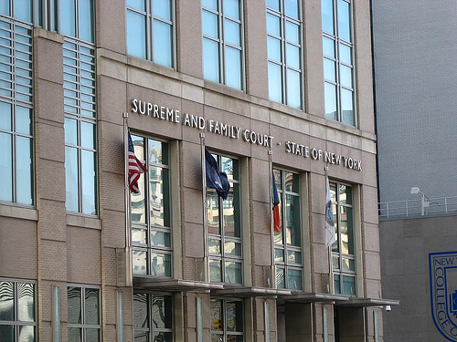
Executive Summary
In February 2016, Brendan O’Hea, Senior Probation Officer / Multi Agency Public Protection Arrangements (MAPPA) Coordinator, was funded by the Rhodes Foundation Scholarship Trust to undertake a research study visit to the Center for Court Innovation in New York to determine whether there were any features of practice in the projects delivered by the Center, which would be transferable to the management of high risk offenders in the public protection arena, in England & Wales. The Research proposal that was submitted revolved around the following question:
- Consider other multi-agency approaches that are designed to reduce re-offending by aiming to achieve a desistance from offending and a subsequent reduction in risk (such as the Problem-Solving approach). Are there aspects of these approaches to working with Offenders, which could be transferred to the management of MAPPA (Multi-Agency Public protection Arrangements) eligible cases?
The interest for this research stemmed from two areas. Firstly, I have had several professional discussions with my manager, the co–chair of the Cheshire Strategic Management Board (SMB) and other SMB members on the subject of how best to rehabilitate dangerous offenders, as traditionally the focus has been on the management of their risk through containment and control measures. This question / goal of how best to rehabilitate dangerous individuals, in addition to containing the risk they pose, appears to be the ‘Holy Grail’ of multi-agency Public Protection work, in my view.
Supervision and monitoring of serious violent and sexual offenders under the MAPPA framework can be shown to be effective in managing and containing the risk posed from dangerous offenders to the public or known parties; the problem of ‘breaking the cycle’ of offending with this group of complex offenders, remains to be a particularly difficult one to progress. There is existing research to support this, including a study indicating a reduction in re-offending rates among sexual and violent offenders released between 2001 and 2004 (which coincided with the introduction of MAPPA in 2001), compared to those released in 1999-2000.). Whilst it is difficult to specifically evaluate the impact of MAPPA on reconvictions, the above mentioned reduction may be associated in part with MAPPA. (Peck, 2011) Additionally, the 2007 Home Office Research paper into the Operation and Experience of Multi-Agency Public Protection Arrangements (MAPPA) identified that MAPPA management could be successful, provided certain conditions for success were met, such as the balancing of restrictive and rehabilitative goals, the individual’s motivation to change and the quality of the supervisory relationship. (Wood, Kemshall, 2007)
Furthermore, whilst the multi-agency approach appears to work in terms of developing a plan to contain the risks, there does not seem to be the same level of success in reducing the risk posed by these individuals through successful redemptive journeys such as successful and lasting change following intervention and treatment approaches.
Secondly, I have had a longstanding interest in the Problem Solving Justice approach. More specifically I am interested in the problem solving approach developed and currently employed in New York Courts and Penal System. I aimed to explore whether this approach to reducing re-offending has principles and strategies, which can be applied to the multi-agency risk management of dangerous offenders, in England & Wales.

Two key projects were visited:
- Brooklyn Mental Health Court, based in the New York State Supreme Court
- Brooklyn Justice Initiatives, based in the Brooklyn Criminal Court.
Each project was delivered by a public - private partnership. The Center for Court Innovation coordinated and delivered the projects working closely with the Bureau of Justice Assistance (BJA - a state agency). Staff were employed by both the Center and the US state.
I acquired considerable learning from the research trip, specifically in relation to the consistent themes and practices that marked an effective or successful outcome of both schemes. However, it must be noted that this learning, for me, was mainly a renewed appreciation of features of practice and delivery of work with offenders, which are occasionally forgotten or marginalised in our work with dangerous offenders in the UK, rather than a big ‘eureka’ moment of observing a new theoretical framework or new type of practice. By seeing the importance of these consistent themes in practical application during my research study visit, I was able to understand and recognise the importance of them in ensuring that agencies within the MAPPA framework, feature rehabilitation-focused goals in our work to manage the risks posed by dangerous sexual and violent offenders in the community.
In summary, the following points are the themes I observed from my Research visit. It is my view that they are learning points for the National Probation Service (North West) to consider:
- The role that consistency of personnel plays in the delivery of restrictive and rehabilitative interventions, as part of single agency and multi-agency risk management.
- The need to consider the value of the Procedural Justice approach in working with individuals likely to be resistant to the implementation of a plan to manage their risk. Procedural Justice is the concept that how individuals consider the justice system is more linked to their perception of the fairness of the process and how they are treated rather than to their perception of the outcomes (US Department of Justice, 2013).
- The importance of ensuring that an offender’s voice is heard in the MAPPA process and the best ways of doing this.
- The value of soft outcomes such as improved relationships with others, self-motivating statements about wanting to change supported by some evidence of capacity and intention. This learning point is strongly linked to Desistance Theory (McNeill, 2009) and Good Lives Model (Ward & Maruna 2007 in PCA 2012).

Introduction & Background
Problem-Solving Courts (PSC) or Problem Solving approaches refers to a Judicial process or criminal justice approach that attempts to address the underlying problems that contribute to criminal behaviour. It is based on the concept of therapeutic jurisprudence whereby the offender is directed to engage in treatment / interventions to reduce their risk of re-offending with their progress being managed by sentencers. The approach originated in the USA in the late eighties but became established in new York in 1993 with the first Community Justice centre being established in Redhook, New York. In 2008, it was estimated that there were almost 3000 Problem Solving Courts.
The Center for Court Innovation (CCI) was founded by former Chief Judge Judith Kaye, who was one of the leading lights in the early Problem Solving Courts. The Center is a public / private partnership that assists courts and criminal justice agencies to decrease crime, provide aid to victims and increase the public’s confidence in the justice system. (NB To reflect the fact that this is a US organisation, I have utilised the US Spelling of ‘centre’ in references to CCI)
In the UK Criminal Justice System, there has been some incorporation of the Problem Solving Court ethos. Drug Rehabilitation Requirements are based on approaches that stemmed from the original Problem Solving Courts in New York and represent a type of Problem Solving Court. More recently, in the North West there have been Problem Solving pilots in Cheshire and Greater Manchester and an established Community Justice Centre in Merseyside.
Interestingly, in the course of completing the Research report, it appears that Problem Solving Courts in the UK have experienced a renewed level of interest from the government. According to the Guardian dated 21 May 2016, ministers have approved the development and subsequent launch of a pilot programme involving a number of Courts, which will be based on the “…New York Style problem solving courts in which judges review the progress of convicted offenders after sentence with the aims of keeping them out of prison.” (The Guardian, May 2016) So it would appear that my chosen research paper has current relevance in relation to future criminal justice practices in the UK.

PART TWO

Rationale for Study (The Question)
This therefore leads me to consider other multi-agency approaches to reducing re-offending through a desistance based approach, which will also deliver reductions in the level of risk posed by the individual. In order to further understanding. I specifically reflected on whether there are aspects of these approaches, which could be transferred to the management of MAPPA eligible cases?
I have previous knowledge and experience of implementing a problem solving approach to engaging offenders to change. From April 2010 – July 2011, I established and led the Problem Solving Court pilot, based in Halton Magistrates in Runcorn, Cheshire. This pilot scheme was well regarded and considered to be effective.
It is my view that the basic principles (on the left) of the problem solving approach, with its primary aim being to address the underlying needs and triggers to an individual’s offending rather than to manage risk, would be compatible with and transferable to a multi-agency risk management agenda such as MAPPA (features of MAPPA practice on the right). To illustrate this, I have prepared the table below:

Problem Solving Court Principles | Features of MAPPA practice
Community Engagement | One of the main drivers for the development of MAPPA was the need to improve information sharing for key decision makers, based in the local community where the offender will be managed.
Collaboration between professionals | One of the main drivers for the development of MAPPA was the need to improve information sharing for key decision makers.
Individualised Justice | Again MAPPA meetings are designed to create a shared understanding of the offender’s risks and needs in order to devise an offender specific action plan to manage those risks, thus ensuring all partners collaborate to the same goal.
Accountable | The offender (MAPPA subject) is advised they are a MAPPA case due to concerns about level of risk they pose and there are consequences (both positive and negative) to their levels of compliance and engagement.
Outcomes | The evaluation of outcomes is a feature of all interaction with offenders.

One of my reasons to consider the Problem Solving Court approach was that I recognised that the Problem Solving model has been expanded to not just attempt to address prolific re-offending with ‘low level’ offenders with a series of offending related needs, as it did initially, but that the Problem Solving model can be observed in work with mental health cases, domestic violence perpetrators and sex offenders. This would suggest the Problem Solving approach can be utilised with individuals whose issues and needs are more complex and indicative of greater level of risk of harm.

Areas of focus for Research
I wanted the opportunity to observe the work of problem solving approaches by spending some scheduled time with staff from the Center for Court Innovation to determine whether there is any feasibility in a problem solving type approach being integrated into MAPPA processes in the NPS North West Division. It remained to be seen as to whether the approach could be used outside of a Judicial process; for example, in the supervision of offenders on licence; and this is something I wanted to explore with Problem Solving experts and innovators.

Learning Goals
The main learning goals of the study visit included:
- Understanding and knowledge of operation of Problem-Solving Court.
- Experience and understanding of how the Problem Solving justice approach is applied to offenders with complex needs and risks such as sex offenders, mental health cases and Domestic abuse offenders.
- Discussion with experienced Problem Solving Court practitioners from a range of agencies to gain their insight on the issues to be overcome in working with more complex offenders in a problem solving framework.
- Access to performance information in relation to effectiveness of Problem Solving approaches in rehabilitating offenders with complex risk and needs.
- Discussion with experienced Problem Solving Court practitioners to gain their views on the feasibility of transferring a Problem Solving approach to the rehabilitative element of management of High Risk MAPPA offenders.

Potential Learning Outcomes

- Identification of good practice themes (which are transferable).
- Understanding of likely levels of resourcing required to implement any proposed good practice learning in the community in Cheshire and the North West.

In summary, the main learning outcome would be to identify an effective way of blending an approach to breaking an offender’s cycle through rehabilitation, where the offender is placed at the forefront of the process, with the need for agencies to manage an offender’s risk, usually through the imposition of restrictions or monitoring measures.

It is the intention to share any learning with NW Public Protection lead, the NW MAPPA Coordinators group and the Ministry of Justice (MOJ) MAPPA unit to prompt a discussion on the wider application of any learning from this proposal.
Methodology
I originally intended to achieve my learning outcomes identified above by:
- Observations of Problem Solving Justice being implemented with a range of different type of offenders (Sex Offenders, Mental Health case, Domestic Abuse offenders)
- Semi-Structured interviews with lead Problem Solving Court practitioners.
- Interviews with Offenders who have participated in Problem Solving Justice.
- Access to performance information in relation to re-offending rates and positive outcomes.

However, in the completion of the study, it became apparent that it was not possible to conduct the offender interviews. This was due to time constraints and issues of custody in the Mental Health Court and due to the last minute change of placement resulting in a visit to the Brooklyn Justice Initiatives rather than the Reentry Court in Harlem.
I conducted two research visits, one to the Brooklyn Mental Health Court and one to the Brooklyn Justice Initiatives.

Templates
The methods and tools for recording observations and occurrences during my research visit to the Mental Health Court included
- A Research Visit Observation Log template, where the location, date and time of the visit were recorded in addition to general discussion points and observations of researcher.
- Data Capture Form 1 (Problem Solving Court Staff), which asked a series of questions to staff from the specific Problem Solving Court in focus, i.e. the Mental Health Court looking at strengths, development areas, barriers, issues and successful outcomes.
- Data Capture Form 2 (Judiciary involved in Problem Solving Court) was designed to solicit the views of the Judge involved in the Problem Solving Court.
- Data Capture Form 1 template was used in both research visits, as was the Research Visit Observation log template. Data Capture Form 2 was intended to be used to solicit the views of the Judge as part of the Research Visit to the Mental Health Court.

During my visit to the offices of Brooklyn Justice Initiatives, the following methods were utilised:
- A Research Visit Observation Log where the location, date and time of the visit was recorded in addition to general discussion points and observations of researcher.
- Data Capture Form 1 (Problem Solving Court Staff), which asked a series of questions about the specific Problem Solving approach in focus, i.e. the work of Brooklyn Justice Initiatives (BJI).
- As this visit took the format of a lengthy meeting with the Director of BJI, discussions focused on its current projects and ethos, in addition to looking at strengths, development areas, barriers, issues and successful outcomes.
- See Appendix 1 for Research Visit Observation Log Template and the Data Capture Form 1 Template (Problem Solving Court Staff) used for the visits to the Mental Health Court and the Brooklyn Justice Initiatives. (O’Hea, 2016)
- See Appendix 1 for Data Capture Form 2 Template - Judiciary involved in Problem Solving Court used for the Mental Health Court visit only. (O’Hea, 2016)

Completed Responses
- In application, it became apparent that there was some duplication from the discussions captured in the Observation Logs for both visits and the questions asked in the Data Capture Forms (1) resulting in some questions being left blank as they had already been answered in previous discussions.
- See Appendix 2 for completed Research Visit Observation Log and completed Data Capture Form 1 (Problem Solving Court Staff) for both the visit to the Mental Health Court and to Brooklyn Justice Initiatives. (O’Hea, 2016)
- Although there was a meeting with the Judge built into the visit this was more of an observational opportunity due to time being limited immediately prior to Court commencing. The Data Capture Form questions were subsequently emailed to the Judge for completion some time afterwards.
- See Appendix 2 for Email from Judge D’Emic entitled ‘Questions / Answers’

PART 3: BROOKLYN MENTAL COURT

Overview & Performance Information

According to the Center for Court Innovation (CCI), “…the Brooklyn Mental Health Court is a specialized court that seeks to craft a meaningful response to the problems posed by defendants with mental illness in the criminal justice system.” (CCI, 2015)
The Mental Health Court aims to address both the treatment needs of those who appear before it, with mental health needs, in addition to addressing the public safety concerns of the community. It does so by using the authority of the Court to link defendants with serious and persistent mental illness with long term treatment as an alternative to custody. In addition, the Mental Health Court aims to improve the court system’s capability to identify, assess, evaluate and monitor offenders with mental illness, as well as creating links between the Mental Health arena and the Criminal justice system, to ensure that the public is protected through the delivery of high quality community-based interventions and services for this Client Group (CCI, 2015).
The Mental Health Court is based on four principles.
- Better Information: An onsite clinical team (consisting of a consultant psychiatrist and Social workers) perform detailed psycho-social assessments of each defendant referred to the Mental Health Court. This allows the Judge to make informed decisions about the participant’s mental health issues and risks to the public, in addition to allowing for individualised treatment plans to be developed.
- Judicial Monitoring: Every participant in the Mental Health Court must return to court regularly to meet with case managers and have a progress review with the Judge, ensuring that the Judge is engaged with the defendant and the defendant aware of seriousness and legitimacy of the process.
- Accountability: The Court uses a broad array of graduated rewards and sanctions to mark progress and setbacks in treatment. The aim is to motivate participants to continue to engage with treatment and make positive lasting changes to their lives. Those who comply with all treatment mandates have their criminal charges dismissed or reduced.
- Coordinated Services: The Mental Health Court works with a broad network of state and not for profit service providers to address interrelated issues of homelessness, unemployment, substance abuse and physical health issues, in related to their mental health conditions and offending behaviour.
In summary, the Brooklyn Mental Health court has reduced both hospitalisations and re-arrests among participants.
I have included some literature from my comprehensive visit pack in order to give an overview of the Mental Health Court, as well as some performance information, up to date as of 29 January 2016. (See Appendix 4 – A)

My Visit
I arrived in New York in the evening of Saturday 06 February 2016. I attended at the offices of the Center for Court Innovation CCI) on 8th Avenue on Monday 08 February to meet with the coordinators of my Research Trip. We discussed the aims of my visit, including revisiting my proposal before they presented me with my itinerary for the week and contact details. I then spent the remainder of the day finalising my planning and preparation for the first of two research visits. The visit to the Brooklyn Mental Health Court took place on Tuesday 09 February 2016. The Court is based in the State Supreme Court Building on Jay Street, Brooklyn.
I was met by Ruth O’Sullivan, the Project / Clinical Director for the Brooklyn Mental Health Court, upon my arrival on the third floor of the King’s County Supreme Court Building, on Jay Street, Brooklyn. Ruth O’Sullivan’s background is in Social Work. My itinerary featured a 30 minute ‘meet and greet’ with the Clinical Director, followed by observing a meeting between her and Judge D’Emic in chambers to discuss the cases in the court calendar for the day. Finally, I was permitted to observe the Mental Health Court in Session, before convening a debrief session with Ruth O’Sullivan. Ruth explained that the court had been in operation since 2002 and was the first Mental Health court in the State. Please refer to Appendix 1 for record of discussions and observations.
One thing that was quickly established during my discussions with the Clinical Director is that there were no ‘rule-out’ offences in terms of seriousness of offending – in fact the Mental Health Court had worked with sexual offenders and those convicted of manslaughter. In discussions with the Clinical Director, it appeared that the commission of a serious offence by someone who has experienced a deterioration in their mental health, either linked to or exacerbated by other risk factors such as absence of suitable accommodation or substance misuse, was a better indicator of suitability than working with someone with persistent low-level anti-social behaviour or acquisitive offending.
Furthermore, the Mental Health Court appeared to be ‘resource rich’ and this was credited in some part to their success - 85% compliance with their court mandate (January 2016, Center for Court Innovation). In terms of conditions for success, Ruth O’Sullivan explained that the availability of an on-site psychiatrist, social workers able to undertake psycho-social assessment reports, an on-site office within the Court House, and a dedicated Assistant District Attorney (prosecuting lawyer) attached to the qualifying Mental Health Court cases, were all contributing factors. In summary, the project’s resources included: two care co-ordinators (who are State employed), two social workers (employed by the Center for Court Innovation), in addition to the psychiatrist. At time of discussion, the Mental Health Court was working with approximately 100 cases with 30 pending the Court process. In my view the project is a labour intensive one but one that clearly has a model for success in dealing with the individuals that they work with.
Referrals for an individual to be dealt with by the Mental Health Court could come from a number of sources including Judges, defence and prosecution lawyers. It was clear that a pre-requisite was some evidence of the presence of a severe and enduring mental illness. The Brooklyn Mental Health Court clinical team then assess suitability for the programme through the medium of detailed psychosocial evaluations, which are then reviewed as a clinical team before being presented to the judge, prosecution and defence. A concise, brief treatment plan is then developed and shared with all parties.

The ethos of the mental health treatment model adhered to by the Court is one of least restrictive care. The Mental Health Court approach is to attempt to treat in the community and wrap services around the individual. The project utilises care coordinators and participants are expected to adhere to 5 day a week programmes. There is not one specific provider of programmes but rather the care coordinator will arrange a programme best matched to the participants’ assessed needs. It is clear that the project will utilise providers of programmes that they may have used previously but it can also be a case of a care coordinator ‘calling round’ to various programme providers to ascertain whether they would be suitable and / or interested to work with the participant. A programme can range from a sheltered accommodation project that offers supervision and in house drug counselling group sessions, cognitive behavioural group work or other similar approaches designed to address emotional coping or substance abuse difficulties. The participants must also comply with any prescribed medication for diagnosed mental health conditions.
It is also noteworthy that the Mental Health Court applies a diversion approach i.e. the aim is to try to divert defendants into mental health outcomes, ideally without or instead of criminal prosecution. It does so through the Court effectively adjourning a participant’s case (if assessed as suitable and responsive) so that they are dealt with by the Court directly intervening to address their assessed underlying needs / risk factors prior to sentence. The period of involvement is a minimum of 12 months to a maximum of 5 years. Participants typically are mandated to return to Court for monitoring every week although it can be less frequent than this dependent on progress.
Prior to observing the Mental Health Court in Session, Ruth O’Sullivan outlined for me the various stages or ‘phases’ a participant progresses through as part of the Mental Health Court:
- Phase 1 – This is the ‘acclimatisation phase whereby a new participant is given time to adjust to what’s expected from them by the Court. Typically this lasts 3 months although it can be less or more, depending on a participant’s needs.
- Phase 2 - This is the engagement phase and again usually lasts 3 months but this is not fixed.
- Phase 3 – Progress – This is where the participant consolidates progress made and works on building stability in the changes they have made in their life.
- Phase 4 – This is approaching the final stages of the Mental Court’s involvement and the Court start evaluating the progress made against the original offending.
- Graduation – This is where the participant formally exits the Project. At this stage, the Judge convenes an impromptu open conference at his bench involving himself, the defence, the prosecution, the Project Director, in the presence of the individual. The Judge asks for a view from legal representatives on both sides as to how they feel the case could be disposed following the individual’s successful engagement with the Mental Health Court. In many cases, this results in the case being dealt with by virtue of a lesser charge and corresponding non-custodial sentence. However, in one case I observed, the Assistant District Attorney advised the Judge that given the outstanding progress that one participant had made then he was prepared to accept an Absolute Discharge and case dismissed ruling, should the Judge be open to this. The case was discharged and it is noteworthy that the original charge against this particular participant was Assault with intent to cause physical injury with a weapon.

Contributing to the review of progress by Court, a brief one page update report is prepared for the Judge by staff from whichever programme the participant is engaging with. This report outlines progress but also identifies any incidents of non-compliance, such as breach of curfew, non-attendance at group sessions or non-adherence with medication regimes. The Judge had the benefit of a discussion of the Court Calendar with the Project Director prior to commencing Court. Given that there were at least 46 cases dealt with on the day that I observed Court. It was particularly impressive how much detailed knowledge about each individual the judge retained, including remembering birthdays, previous discussions, advice on how best to engage specific individuals based on the individual needs or condition, and culturally significant dates (Judge D’Emic wished one Chinese American participant Happy New Year in recognition of the Chinese New Year).
During the various cases I observed, it was significant that every time a participant achieved one of these Phases, the Judge called them to approach the bench where he handed them their Phase / Graduation certificate and requested that the whole court room applauded them. This clearly had a hugely motivational effect on many participants, based on my observations.
However, the Judge also retained a significant level of authority evident when faced with reports of non-progress. I observed several occasions where the Judge reminded the participant of the Court’s mandate including the authority to remand into custody and sentence them for the offence in recognition of continued non-compliance. He also had the ability to issue a warrant when a participant did not attend Court and their location was unknown to their legal representative and other support agencies. In the main, however, it was clear that the Judge attempted to utilise his authority to achieve improved engagement by issuing warnings or increasing the frequency of reporting to the Court during periods of lapse or less than perfect compliance.

My Observations
Based on my observational visit and discussions with staff and Judge D’Emic, I note the following:
- Theoretical framework: The Brooklyn Mental Health Court is firmly rooted in the Risk – Need – Responsivity or RNR Principles (Andrews & Bonta, 2003). The risk of harmful re-offending is assessed and understood, in addition to the individualised needs of the participant. A plan is implemented designed to be responsive to the individual’s risks and needs, but also their ability and motivation to engage. Furthermore, the Brooklyn Mental Health Court also adheres to evidence-based strategies for working with offenders including assessment (using validated tools to determine risks and needs, treatment (applying RNR principles when matching offenders to interventions), deterrence (imposing certain and consistent consequences in response to non-compliance, collaboration (obtaining ‘buy in’ and participation from a strategic and operational level from a range of criminal justice agencies, and finally, a procedural justice approach (establishing fair and consistent procedures to treat offenders based on their voice being heard, them being treated with respect, offenders viewing decision makers as neutral and trustworthy and also understanding the reasons for their decisions and their responsibilities, as well as feeling that decisions makers are helpful with a genuine interest in their needs and personal circumstance).

- Multi-Agency element: It was very apparent that the practice of the Brooklyn Mental Health Court is underpinned by the principle of co-operation, not only between the state (Bureau of Justice Administration) and the Center for Court Innovation but also between the Court, the Prosecution, various defence lawyers, treatment and accommodation providers. In discussions, Clinical Director Ruth O’Sullivan indicated that there is no real issue with Provider buy in or engagement with the work of the Court as they understand that the participant is subject to the mandate of the Court and any reported increase in risk or concerns are dealt with swiftly and effectively by the Court. Furthermore, in discussions about accommodation provider, whilst Ruth O’Sullivan identified that difficulties in obtaining suitable affordable accommodation in the Brooklyn area were occasionally a barrier to a participant being able to comply with the Problem Solving Court, it was clear that she believed that these difficulties were rooted in the simple lack of suitable accommodation rather than any reluctance or reticence on the part of accommodation providers or specialist facilities. This is significant, in my view given that the National MAPPA team has recently written to MAPPA Coordinators and Chairs of the Strategic Management Board to advise that concerns have been raised nationally about accommodation issues being a national recurring issues in the Management of MAPPA offenders. In fact, this issue is identified as a national priority for the 2016 /17 business year, by the National team.

- Risk still a feature: Whilst the Mental Health Court is clearly focused on delivery of outcomes for participants intended to aid their rehabilitation and empower them to make lasting changes to their lives, it was clear that they also had a dual focus on the risk of the individual they were working with. This was evidenced by the in Court discussions and progress report where evidence of substance misuse or non-compliance with mental Health Medication was viewed seriously in terms of increase in risk. The Mental Health Court had a clear strategy for responding to increase in risk, consisting of: increased reporting to Court, remanded for a brief period of time (and then re-released when required) by the Judge to achieve a period of stability and gain control of the situation, formal exit from the Mental Health Court resulting in transfer into the mainstream judicial process for sentencing for their original offence.

- Conditions for Success: In my assessment, the primary condition for success is the trust that exists between the participant and the Court but also the trust that exists between the various professionals involved in the project, including the Judge, the Clinical team, the defence and prosecution and also treatment providers. Simply put, to ensure that offenders feel fairly treated and that their voice is heard then “….Trust is Crucial.” (Fisler, 2005) Ruth O’Sullivan echoed this when she highlighted that the judicial relationship is at the heart of any successful outcomes of the Mental Health Court. Additionally, it was clear that the Court had very clearly defined boundaries reinforced by the judge himself but also the other agencies involved. During the Court session I observed, it was evident that participants respected these boundaries. This was due primarily to participants being able to have a sense of consistency and familiarity. In other words, they knew what to expect when they attended Court or progressed through the project, due to the consistency in approach by staff but also the consistency in staff and locale due to the localised model of delivery of the Mental Health Court (same Court room, same Judge, pool of bespoke defence lawyers, same Assistant District Attorney, same Court personnel). Another condition for success was the relatively high resourcing levels of the Clinical Team, according to Ruth O’Sullivan. Although there had been a reduction in staffing since the scheme started in 2002, the team was still ’resource rich’ to reflect the labour intensive nature of the work. Judge d’Emic also echoed this view highlighting the additional resources of the Court as a positive.

- Successful Outcomes: According to an Article in the Wall Street Journal, “Brooklyn’s mental-health program has become a model for localities try to deal with,...the increasing number of mentally ill people filling the nation’s prisons.” (Wall Street Journal, 2006). In Ruth O’Sullivan’s view, a successful outcome is obviously a participant successfully ‘graduating’ from the scheme, having their case dismissed or conditionally discharged, staying out of prison, substance free and compliant with their medication regime. The summary of Brooklyn Mental Health Court as of January 29 2016 (Page 18) clearly outlines statistical evidence of successful outcomes to illustrate this view. However, Ruth O’Sullivan went on to comment that successful outcomes can be more personal for participants such as feeling ‘part of something’ rather than being feeling isolated and an outsider by virtue of their life circumstances, condition or actions. Participants also, in her view, notice when they experience being ‘in crisis’ less frequently due to the support and stability court monitoring and their engagement with services provides for them. Ruth O’Sullivan felt that these ‘soft’ outcomes linked primarily to the participants’ sense of self and progress to a new, better life free from offending or self-destructive behaviours, were equally as important as indicators of success. Judge D’Emic offered the view that a successful outcome in the Mental Health Court can be varied, dependent on the defendant’s current status and the extent to which their mental health issues are debilitating. He went on to comment that there are Mental health Court graduates who are employed and maintain their own tenancy, whilst they are those who cannot live independently but no longer commit offences. In Judge D’Emic’s words: “It is the hope of the court, that regardless of the extent of the defendants illness, that in fulfilling the Court Mandate, the bad habits of criminal behaviour are replaced by the good habits of medication compliance, remaining in treatment and socialization. So it is not a one size fits all determinative.” (Judge D’Emic, 2016)

His Honour Judge Matthew D’Emic in Session at Mental Health Court,
New York State Supreme Court, Brooklyn

PART 4:BROOKLYN JUSTICE INITIATIVES

Overview & Performance Information
As previously indicated, due to a last minute amendment to my itinerary, instead of observing the Reentry Court in Harlem, I had a meeting with Jessica Kay; Project Director of Brooklyn Justice Initiatives (BJI). BJI is based in the Criminal Court Building, 120 Schemermorn Street, Brooklyn. Last year (2015), there were over 100,000 appearances at the Brooklyn Criminal Court.
According to the Center for Court Innovation (CCI) fact sheet: Brooklyn Justice Initiatives aims to create a new way of dealing with misdemeanour (minor) and non-violent felony (major) crimes in Brooklyn, which has a population of approximately 2.5 million people. The project is staffed by a team of court-based social workers, case managers and court liaison staff. Their purpose is to use the arrest and Court appearance of an individual as an opportunity to change the defendant’s life direction and avoid the detrimental impact of custody. The project attempts to do this by providing meaningful pre-trial supervised release and post-conviction sentencing options (Center for Court Innovation, 2015).
I have included some fact sheets from my visit in order to give an overview of the main work streams of Brooklyn Justice Initiatives. (See Appendix 4B) I shall explore this further in the ‘My Visit’ section to reflect the discussions I had with Jessica Kay.

Brooklyn, New York including the Brooklyn Bridge

My Visit
The visit to the Brooklyn Justice Initiatives (BJI) office took place on Thursday 11 February 2016. The Court is based in the Kings County Criminal Court Building on Schermerhorn Street, Brooklyn.
I was met by Jessica Kay, the Project Director of BJI, upon my arrival. Jessica Kay is a Social worker. This visit differed from the visit to the Mental Health Court as it primarily consisted of a face to face meeting with the BJI director. The meeting lasted two hours, during which I was given a very detailed and comprehensive overview of the work of BJI, in addition to discussing my role and any transferable themes or concepts. I found my host to be incredibly knowledgeable and willing to share her considerable knowledge. Please refer to Appendix 3 for record of discussions and observations.
Jessica Kay began by setting the context of the work on BJI within the purpose of the Center for Court Innovation, which is to attempt to reform justice delivery in the United States of America and elsewhere. Jessica Kay described three main areas of CCI’s work:
- Development and Implementation of Operational Programmes – The CCI currently has 25 operational programmes in service (of which the Brooklyn Mental Health Court is one). This is the ‘in the trenches’ role of CCI in Jessica’s view. The operational programmes are all underpinned by the aim to reduce the use of unnecessary custodial sentences and they do so by allowing new approaches to justice delivery to be implemented and tested whilst also allowing stakeholders (courts, Judges, prosecuting & defending lawyers, correctional services, mental health & substance misuse services, accommodation projects) to come together to identify best practice.
- Undertaking and publication of Research – The CCI has dedicated research teams identifying what is effective practice and the circumstances that underpin this effectiveness.
- Technical Assistance – The Center for Court Innovation very much sees itself as a strong advocate for Justice Reform and it progresses this role by sharing its lessons with other criminal justice professionals worldwide through its website, publication of its fact sheets and ‘How to’ guides, in addition to facilitating research visits similar to mine.
Brooklyn Justice Initiatives was set up in 2013 to deliver pre- and post-justice services in the Brooklyn area in order to assist offenders and work towards a disposition or outcome outside of the Criminal Justice System (where appropriate). (See Appendix 4 B, pages 51-52 )
In summary, its aims are to help the person AND achieve efficient justice delivery. BJI has a number of Court based projects and is very much at the heart of the justice system in Brooklyn, working with different judges and legal representatives.
In relation to staffing and resourcing, Jessica Kay explained that currently Brooklyn Justice Initiatives has a staff of 13, which will ultimately increase to 20 over the coming year. The team consists of a mixture of Senior Case Managers - who are qualified to M.SC. in Social Work level, Case Managers – qualified to BA in Social Work level, Court Liaison (who act as a link between BJI and the court room by interacting with lawyers and Judges) - in the main these staff are non-practising lawyers or hold M.Sc. qualifications in Criminal Justice.

In terms of practice, the starting point for BJI staff in working with individuals as part of the court process is the detailed psychosocial reports prepared for the Court by BJI staff at point of sentence. These reports attempt to get to the root of the underlying reasons for offending and anti-social behaviour by exploring an individuals’ criminal history and previous convictions, examining the relationship between what is occurring in their life now and their criminal history, identifying substance misuse history (length, severity and nature of misuse), trauma history (including systemic trauma), housing history / issues, education history, other criminogenic risk factors, including criminal thinking (which is usually addressed via cognitive behaviour based treatment programmes).
During discussions about the impact of trauma on individuals and other practical barriers to people leading law abiding lifestyles, Jessica Kay and I had a discussion about housing in the Brooklyn area. She described a housing ‘crisis’ in New York due mainly to the lack of appropriate, accessible and suitable accommodation. In her opinion the housing shelters were unsafe and the supported housing provision was a difficult system for professionals to navigate let alone vulnerable individuals with offending, substance misuse or mental health difficulties. Housing applications can take months, even years. However, Jessica Kay indicated this was a housing capacity (lack of appropriate housing stock) issue, rather than any systematic bias towards working with those known to the criminal justice system.
As indicated on the BJI Fact sheet on pages 51 and 52 in Appendix 4 B, BJI have a number of programmes in operation at the time of my discussions:
- Young adults. This is a diversion scheme for 16-24 year olds, where the individual’s needs and risks are identified and the BJI work with lawyers and the Court, in addition to engaging the participants in order to link the young offender into available social and community based services through the means of a non-criminal Court disposition.
- Human Trafficking interventions. This approach aims to work with sex trafficking victims in a way that recognises their trauma but also builds on their strengths. The aim is to break the cycle of arrest and re-victimisation.
- Pre-Trial Supervision. This intervention identifies bail eligible cases that would usually not be able to access bail as they have no means to financially cover it. The BJI team undertake a detailed assessment of risk and need and offer to supervise the individual until the case is heard by the Court and a disposition reached. Jessica Kay offered her personal view that the need for this approach stems from a feature of the US Justice whereby Judges are not permitted to take dangerousness into account in bail decisions. In Ms Kay’s view this has the unintended ‘perverse’ impact of low risk, financially disadvantaged people remaining in prison until trial, which subsequently has a significant detrimental impact on their wellbeing.
- Mental Health Diversion. This intervention originated from research that highlighted the disproportionate amount of time mentally disordered defendants spent in custody compared to non-mentally disordered defendants. The intervention looks at receiving referrals from mental health practitioners based at Riker’s Island prison. It aims to offers alternatives to detention before plea (pre-trial) and offer alternatives to custody post trial for mentally disordered offenders.

My Observations
I make the following observations based on my visit to Brooklyn Justice Initiatives, including my discussions with Jessica Kay:
- Recurring Themes: It was apparent from my visit to Brooklyn Justice Initiatives that its underpinning ethos was based on thorough and accurate assessment and identification of risk and need, effective communication to all stakeholders to create a sense of joint enterprise, and implementation of actions needed to achieve good outcomes with individuals.

- Theoretical Frameworks: It was clear from discussions with Ms Kay that once again, Procedural Justice (the perception of the participant that the system they are involved in is being fairly and constantly administered to them) is a driving tenet of the work they do. This underlined the importance of accurate risk assessment and effective communication between Courts, services and legal representatives, facilitated by the BJI Court Liaison staff. Furthermore, Ms Kay felt that Motivation Interviewing (Miller & Rollnick, 1994) approaches played a key part in encouraging participants to reflect on their lives, identify things they wanted to change and to then empower them to do so, thus achieving participant ‘buy in’ to change.

- Barriers to Successful Outcomes: It was clear from discussions and from reading the literature supplied from BJI, that from a practical perspective, the competing interests of stakeholders can sometimes impact on successful outcomes. Additionally, systemic barriers such as individuals navigating the accommodation Housing provision systems or knowing how to access appropriate support systems can also be barriers to effective change. Jessica Kay elaborated to explain that these systemic barriers can in turn impact on an individual’s core needs (shelter, feeling safe etc.), which makes it difficult for professionals to empower and encourage change.

- Conditions for Success: Jessica Kay summarised positive outcomes post plea as resulting in an individual whose needs are stabilised, are engaged in the relevant treatment and are subject to a non-criminal disposition. In terms of a pre-trial case, success would be someone being safely supervised in the community pending trial, not being re-arrested and avoiding pre-trial detention. However, Ms Kay commented that if learning about an individual or an element of practice is made, even if a case is returned to prison or ‘fails’ treatment, then this in her view is still a success. Furthermore, Ms Kay indicated that for an intervention to work, participants need to feel that they have a voice in proceedings and this is the main role that BJI serves. The offender’s voice is evident in an accurate assessment process that needs to pay heed as to how the offender’s needs are linked to offending behaviour. This is then communicated to all relevant stakeholders so that all necessary parties are working to the same goal. Interestingly, Ms Kay commented that one of the learning points from implementation of the BJI approach was that there needs to be early stake holder involvement in planning stages and that stakeholders too need to feel that their voice is heard.

CONCLUSION
Review of Learning Outcomes
As indicated on page 7, the envisaged learning outcomes of this research study were as follows:
- Understanding and knowledge of operation of Problem-Solving Court.
- Experience and understanding of how the Problem Solving justice approach is applied to offenders with complex needs and risks such as Sex offenders, mental health cases and Domestic abuse offenders.
- Discussion with experienced Problem Solving Court practitioners from a range of agencies to gain their insight on the issues to be overcome in working with more complex offenders in a problem solving framework.
- Access to Performance Information in relation to effectiveness of Problem Solving approaches in rehabilitating offenders with complex risk and needs
- Identification of good practice themes (which are transferable).
- Discussion with experienced Problem Solving Court practitioners to gain their views on the feasibility of transferring a Problem Solving approach to the rehabilitative element of management of High Risk MAPPA offenders.
- Understanding of likely levels of resourcing required implementing any proposed good practice learning in the community in Cheshire and the North West.

As illustrated in the body of this report and in the supporting appendices, I have achieved Learning Outcomes A to E in that I have obtained knowledge and understanding of the operation of Problem Solving courts and approaches in New York, especially how the approach is delivered to those who committed serious offences and have complex needs such as mental health issues. I have achieved these learning outcomes through discussions with staff from the Center for Court Innovation (CCI), in addition to verbal and written contributions from Judge Matthew D’Emic, presiding judge of the Brooklyn Mental Health Court. This work has allowed me to gain an idea of the main good practice themes, which I will discuss at a later stage. I will also consider learning outcomes F and G – namely, can the identified good practice themes be transferred to the Management of MAPPA offenders in England and Wales (specifically Cheshire and North West) and what would be required in practical terms to achieve this?
Supervision and monitoring of serious violent and sexual offenders under the MAPPA framework can be shown to be effective in managing and containing the risk posed from dangerous offenders to the public or known parties; the problem of ‘breaking the cycle’ of offending with this group of complex offenders, remains to be a particularly difficult one to progress. There is existing research to support this, including a study indicating a reduction in re-offending rates among sexual and violent offenders released between 2001 and 2004 (which coincided with the introduction of MAPPA in 2001), compared to those released in 1999-2000.. (Peck, 2011) Additionally, the 2007 Home Office Research paper into the Operation and Experience of Multi-Agency Public Protection Arrangements (MAPPA) identified that MAPPA management could be successful, provided certain conditions for success were met, such as the balancing of restrictive and rehabilitative goals, the individual’s motivation to change and the quality of the supervisory relationship. (Wood and Kemshall, 2007)
The multi-agency approach appears to work in terms of developing a plan to contain the risks, however, it appears to be much more ‘hit and miss’ in reducing the risk posed by these individuals, through successful redemptive journeys featuring lasting change, following completion of accurately targeted interventions and / or engagement in ongoing treatment approaches.
Specific Learning from Visit
Overall, I am of the view that there was considerable learning acquired from my research trip, specifically in relation to the consistent themes and practices that marked an effective or successful outcome of both schemes. This learning was not a new theoretical framework or method of practice or big ‘eureka’ moment but rather a renewed appreciation of features of practice and delivery of work with offenders, which are occasionally forgotten or marginalised in our work with dangerous offenders in the UK. By seeing the importance of these themes in practical application during my research study visit, I was able to understand and recognise the importance of them in ensuring that rehabilitation goals are also pursued in our efforts to successfully manage the risks posed by dangerous sexual and violent offenders in the community.
- Firstly, the importance of accurate and detailed risk assessments that identify risk and need AND build a plan with realistic, achievable time-bound goals to manage or address these risks and needs cannot be underestimated. Whilst this concept is well known and accepted by Probation, Prison Service and the Police, it is clear that risk assessment and planning is an area in which we should consistently be striving to improve and learn, to ensure that our assessments and plans as professionals are fit for purpose. It is hoped that recent initiatives by the Ministry of Justice and the National Offender Management Service (NOMS) to develop and distribute a risk management improvement tool for Probation and the publication of new draft guidance on MAPPA Risk Management plans by the national MAPPA Team will drive progress in this area.
- Secondly, I was struck by how important the concept of participant’s or offender’s voice was in the work of the Problem Solving justice approaches I observed, especially the Brooklyn Mental Health Court. This is very closely linked to the importance of procedural justice, as an underpinning tenet in both projects I observed. Professor Tom Tyler of Yale University identifies 5 dimensions of procedural justice – voice, respect, neutrality, understanding and helpfulness. (Tyler, in USDOJ 2013)
- The value of having a specific Mental Health court where specialist mental health practitioners guided and influenced the decisions of the Judge and other professionals, was also evident during my observation of the Mental Health Court in session. The Court was able to work towards its aims of reducing re-offending and empowering lasting change among participants in a way that was well tailored to participants’ individual health needs.

How can we implement learning?
In terms of transferability of effective practice and successful outcomes from the project I visited to the management of MAPPA case in England and Wales, I believe that incorporating this concept is something that could be explored further. I have underlined key transferable learning below.
MAPPA meetings traditionally consist of an agency or agencies (usually Police, Probation or Prison Service) presenting concerns about an individual in the community, supported by a detailed risk assessment (and sometimes other risk information). The agencies around the MAPPA table then collaborate to devise a plan to manage the risk identified by the lead agency or other agencies. Traditionally the offender’s voice is missing in this process. The work of MAPPA is rooted too in the Risk-Need-Responsivity (RNR) model. They are very much ‘done to’ and whilst specific needs such as mental health, homelessness or substance misuse are often identified, there is little effort to pay heed to the impact this will have in successfully reducing the risk of the individual in long term, with the focus instead being on managing and containing the risk in the here and now. Whilst it is true that some models of MAPPA delivery do involve multi-agency risk assessments and asking the offender to self-assess (such as the Four Pillars Model devised by Professor Hazel Kemshall of De Montfort University), it is my view as a MAPPA coordinator that more consideration should be given to examining and understanding what the individual subject to MAPPA management is telling us about their perceptions of their own risk and their concept of a meaningful future and these disclosures becoming a fundamental part of any plan to manage the risk here and now but also to support the rehabilitation of the individual in the long term.
Furthermore, it is my view that the individual subject to MAPPA management should be given a very clear detailed explanation as to the different elements of the risk management plan that has been developed by the MAPPA panel. It is wholly accepted that this may not always be possible with elements of a risk management plan pertaining to Victim Safety. However, where an offender is expected to undertake treatment, reside in a specific location, adhere to restrictive or prohibitive measures then a detailed evidence based rationale should be provided to them.
In addition to this rationale, individual MAPPA subjects should be very clear about what successful engagement with MAPPA looks like. This would require MAPPA to be consistent in how it responds to progress (i.e. if a measure is implemented and the individual advised it is for a specific timescale or purpose then timely consideration should be given to reviewing or removing this measure if it is no longer needed). It is important to avoid the offender having the perception of ‘moving goalposts’ as this impacts on trust and levels of motivation to change / comply. It is also important to take into account external and internal protective factors and steps taken to change so that efforts to desist from crime are supported as well as opportunities to offend being managed. This amalgam of the RNR model with desistance principles is referred to by the Probation Chiefs’ Association Research Analysis (PCA, 2012)
Linked to the concept of the offender voice, it is my contention that the chairs of a MAPPA panel should have a greater level of visibility in the offender’s eyes. It is part of some MAPPA (using 4 Pillars model of delivery) areas’ practice for an offender to be sent a templated letter advising them that they are subject to MAPPA and can contribute via their Offender Manager. However, in my view, a personalised letter from MAPPA chairs to an individual advising them that they are subject to MAPPA level 2 or Level 3 management, the reasons for that, and the risks that they pose which MAPA are attempting to manage, would be an effective way of soliciting an offenders voice in order to achieve ‘buy-in’ not only into the plan to manage their risk, but potentially to efforts to achieve long term change.
I also see the merits in chairs playing an active role in communicating to the MAPPA subject at key times, most notably to reward or commend them for progress, or to challenge them directly when they are not complying. This approach would mirror the consistent message given by Judge D’Emic in his delivery of the Mental Health Court where participants were very clear about the consequences of non-compliance but also appeared to be highly responsive to positive feedback from a significant authority figure. In this case, the MAPPA chairs would ‘substitute’ for the role played by the Judge to reflect the differences in situation.
Finally, the role of specialist practitioners is a key feature of the success of the Mental Health Court. Although certain MAPPA areas are well supported by Forensic Support teams and other specialist Forensic Mental Health practitioners, my experiences in observing the Mental Health Court lead me to question whether there is merit in mental health practitioners playing a greater role in MAPPA meetings concerning the management of mentally disordered offenders. Mental health practitioners can and do refer cases for MAPPA level 2 and 3 management, whilst also acting as lead agency for MAPPA eligible cases in treatment subject to Hospital Orders. It is my view that consideration should be given to the feasibility of Mental Health lead practitioners acting as co-chairs in meetings involving Mentally Disordered Offenders and these meetings themselves could be delivered using a specialist format that takes into account the need to balance treatment, skills deficits, emotional coping issues and welfare needs with other risk management concerns. This issue would require further exploration and research to progress.

Next Steps
In summary, the following points are learning points for the National Probation Service (North West) to consider as to how to take forward. I propose to share this report with the Cheshire SMB Chair and NPS NW Public Protection Lead, in addition to the National MAPPA team, if requested:
- The role that consistency of personnel (including specialist roles) plays in the delivery of restrictive and rehabilitative interventions, as part of single agency and multi-agency risk management.
- The need for high quality risk assessments and plans that target both risk factors but also offender needs that would act as barriers to meaningful, high quality, offence free existence. These plans would need to be clearly communicated to MAPPA subjects with right to input / contribute.
- The need to consider the value of the Procedural Justice approach in working with individuals likely to be resistant to the implementation of a plan to manage their risk. Procedural Justice relates to the concept that how individuals consider the justice system is more linked to their perception of the fairness of the process and how they are treated rather than to their perception of the outcomes (US Department of Justice, 2013). In order to progress this learning point, it may require more visible liaison between MAPPA Subjects and MAPPA Chairs to reward progress and challenge non-compliance.
- The importance of ensuring that an offender’s voice is heard in the MAPPA process and the best ways of doing this.
- The value of outcomes such as improved relationships with others, self-motivating statements about wanting to change supported by some evidence of capacity and intention, and the impact that these outcomes have on the individual’s efforts to change. This learning point is strongly linked to Desistance Theory (McNeill, 2009) and Good Lives Model (Ward & Maruna 2007 in PCA 2012).
- The potential merits of specialist Mental Health MAPPA meetings co-chaired by Mental Health practitioners.

Bibliography & References
Andrews and Bonta (2003) in Stephens, K (2012) Research & Analysis Review – Desistance & Offender Engagement, Probation Chiefs Association, 2012
Fisler, C (2005) Building Trust and Managing Risk – A Look At A Felony Mental Health Court, Psychology, Public Policy and Law, Volume 11 No.4 pp587-604, 2005
Mc Neil, F (2009) Towards effective practice in Offender Supervision, The Scottish Centre for Crime & Justice Research (SCCJR), January 2009. Available at:
http://www.sccjr.ac.uk/pubs/Towards-Effective-Practice-in-Offender-Supervision/79

Miller, W and Rollnick, S (2002) Motivational Interviewing (2nd Ed): Preparing People for Change, Guilford press, 2002

Peck, M (2011) Patterns of reconviction among offenders eligible for Multi-Agency Public Protection Arrangements (MAPPA), Ministry of Justice Research Series 6/11, June 2011.
Stephens, K (2012) Research & Analysis Review – Desistance & Offender Engagement, Probation Chiefs Association. Available at:
http://probationchiefs.org/desistance-offender-engagement/

Tyler, T (1990), in Gold, E and Bradley, M (2013) The Case for Procedural Justice: Fairness as a Crime Prevention Tool, US Department of Justice, Vol 6 Issue 9 September 2013. Available at:
http://cops/usdoj/html/09-2013/fairness_as_a_crime_prevention_tool

Ward and Maruna (2007) in Stephens, K (2012) Research & Analysis Review – Desistance & Offender Engagement, Probation Chiefs Association, 2012
Wood, J and Kemshall H (2007) The Operation and Experience of Multi-Agency Public Protection Arrangements (MAPPA), London: Home Office.

Print Media
Bowcott, O, US Style problem-solving courts planned for England and Wales, The Guardian 21 May 2016.
Fields, G Trial Run: In Brooklyn - A Route out of Jail for the Mentally Ill, The Wall Street Journal, 21 August 2006.

Website
Various articles, fact sheets, guidance documents accessed via the Center for Court Innovation Website. Available at: http://www.courtinnovation.org

APPENDIX 1
Pages 28 – 33 contain the blank Data Capture and Observation Logs designed by me for the purpose of the research visit.
Problem Solving Court Research Visit
Date: | Location:
Name of Court:

Observations:

Additional Sheet (if Required)

Data Capture Form 1 (Problem Solving Court Staff)
Practitioner Questions
- Please can you describe to me, in a few words, the Problem Solving Court that you are involved with – i.e. what is the Problem Solving Court approach?
_______________________________________________________________________________________________________________________________________________________________________________________________________________________________________________________________________________________________________________________________________________________________________________________

- What is your involvement in this Court?
_______________________________________________________________________________________________________________________________________________________________________________________________________________________________________________________________________________________________________________________________________________________________________________________

- How long has this Court been in operation?
_______________________________________________________________________________________________________________________________________________________________________________________________________________________________________________________________________________________________________________________________________________________________________________________

- What makes this approach to delivering Justice different from other courts – in other words – what is the difference between this Court and others?
_______________________________________________________________________________________________________________________________________________________________________________________________________________________________________________________________________________________________________________________________________________________________________________________

- What do you think are the strengths and development areas of the Problem Solving Court approach?
_______________________________________________________________________________________________________________________________________________________________________________________________________________________________________________________________________________________________________________________________________________________________________________________

- Do participants have to volunteer or opt – in to be dealt with by the Problem Solving approach? How do you measure “buy-in” from participants?
_______________________________________________________________________________________________________________________________________________________________________________________________________________________________________________________________________________________________________________________________________________________________________________________

- What, in your opinion, are the differences between this Problem solving Court (Mental Health Court / Reentry Court) and other types of Problem Solving Courts?
_______________________________________________________________________________________________________________________________________________________________________________________________________________________________________________________________________________________________________________________________________________________________________________________

- What are the main issues and barriers for the Court in working with individuals as part of the Mental Health Court / Reentry Court?
_______________________________________________________________________________________________________________________________________________________________________________________________________________________________________________________________________________________________________________________________________________________________________________________

- What, in your opinion, does a successful outcome look like for someone who’s been part of the problem solving Court process?
_______________________________________________________________________________________________________________________________________________________________________________________________________________________________________________________________________________________________________________________________________________________________________________________

- (PSC Staff) Is there Performance information that indicates the effectiveness of the Problem Solving Court approach (compared to other approaches)?
_______________________________________________________________________________________________________________________________________________________________________________________________________________________________________________________________________________________________________________________________________________________________________________________

- (PSC Staff) Are there any patterns or themes evident in Performance information about why Problem Solving Court approach works or identifiable pre- requisite conditions for success?
_______________________________________________________________________________________________________________________________________________________________________________________________________________________________________________________________________________________________________________________________________________________________________________________

- What would you say are the main differences between the Mental Health Court and the Reentry Court?
_______________________________________________________________________________________________________________________________________________________________________________________________________________________________________________________________________________________________________________________________________________________________________________________

Appendix 2
Pages 34 – 43 contain completed Data Capture, Observation Logs and Judge’s feedback from the Mental Health Court visit.

MH Data Capture Form 1 (Problem Solving Court Staff)
Practitioner Questions
- Please can you describe to me, in a few words, the Problem Solving Court that you are involved with – i.e. what is the Problem Solving Court approach?
_______________________________________________________________________________________________________________________________________________________________________________________________________________________________________________________________________________________________________________________________________________________________________________________

- What is your involvement in this Court?
_______________________________________________________________________________________________________________________________________________________________________________________________________________________________________________________________________________________________________________________________________________________________________________________

- How long has this Court been in operation?
_______________________________________________________________________________________________________________________________________________________________________________________________________________________________________________________________________________________________________________________________________________________________________________________

- What makes this approach to delivering Justice different from other courts – in other words – what is the difference between this Court and others?
Risk can be reduced – Alc – Meds _______________________________________________
_________________________________________________________________________________________________________________________________________________________________________________________________________________________________

- What do you think are the strengths and development areas of the Problem Solving Court approach?
Weakness - Major Weakness – Housing – How few general resources there are /_________
Aim of de-institutionalisation but lack of treatment___________________________________________________________________
Move away from Day Centre to back to work________________________ ______________
Lose some info as assessment based on presenting case - risk__________________________
Strengths – Resource Rich – Psychologist + Social worker ___________________________
Local dedicated Personnel____________________________________________________
Judge – Aim to please - Judicial relationship ______________________________________

- Do participants have to volunteer or opt – in to be dealt with by the Problem Solving approach? How do you measure “buy-in” from participants?
Buy in – form of agreeing to take meds and go to programmes _____________________
Participant can see progress – less crisis not hospitalisation - secondary benefit_____________________________________________________________________
___________________________________________________________________________

- What, in your opinion, are the differences between this Problem solving Court (Mental Health Court / Reentry Court) and other types of Problem Solving Courts?
_______________________________________________________________________________________________________________________________________________________________________________________________________________________________________________________________________________________________________________________________________________________________________________________

- What are the main issues and barriers for the Court in working with individuals as part of the Mental Health Court / Reentry Court?
- Staffing shortages – staff not replaced___________________________________________
- 6 – 4 but cases the same ____________________________________________________
Start – ICM – money smaller caseload - past________________________________________

- What, in your opinion, does a successful outcome look like for someone who’s been part of the problem solving Court process?
Phase System________________________________________________________________
Must not get high or taking meds________________________________________________
Graduation from Court – Participant offender_____________________________________

- (PSC Staff) Is there Performance information that indicates the effectiveness of the Problem Solving Court approach (compared to other approaches)?
_______________________________________________________________________________________________________________________________________________________________________________________________________________________________________________________________________________________________________________________________________________________________________________________

- (PSC Staff) Are there any patterns or themes evident in Performance information about why Problem Solving Court approach works or identifiable pre- requisite conditions for success?
Somewhere to go to feel part ___________________________________________________
___________________________________________________________________________
___________________________________________________________________________

- What would you say are the main differences between the Mental Health Court and the Reentry Court?
_______________________________________________________________________________________________________________________________________________________________________________________________________________________________________________________________________________________________________________________________________________________________________________________

- How is the Problem Solving Court (Reentry / Mental Health Court) resourced differently to other Courts? Does this make a significant difference to the likelihood of a successful outcome?
_______________________________________________________________________________________________________________________________________________________________________________________________________________________________________________________________________________________________________________________________________________________________________________________

Matthew D’Emic <mdemic@nycourts.gov>  01/06/2016 19:48 | To "Brendan.O'Hea@probation.gsi.gov.uk" <Brendan.O'Hea@probation.gsi.gov.uk>  cc  Subject questions/answers
Dear Brendan:

I am sorry for the delay in answering your questions but wanted to gather my thoughts.

First, I believe the strengths of the mental health court are several. Traditionally, there were only two options to criminally accused persons who suffer from a mental illness: a plea of guilt or of not guilty by reason of insanity (NGRI), or a trial. Most defense attorneys are wary of NGRI pleas because the client will remain basically in a prison hospital until treating psychiatrists believe he is no longer a danger. This could be longer than a prison term. Also, trials are often not feasible because of the amount of evidence the prosecutor has. That leaves a guilty plea, perhaps to the minimum prison term, as the best option. The mental health court presents a third way. The defendant is referred to the court, evaluated by a psychiatrist and social worker. If he suffers from a serious and persistent mental illness then he is eligible for admission to the court. Although the accused pleads guilty, sentencing is deferred. The accused goes into treatment and, if successful, after 12-18 months, the plea is vacated and the case dismissed as a general rule. The strength of the court is that it provides an alternative to incarceration option to mentally ill defendants. A second strength lies with the procedural justice of the court, i.e., the accused is listened to. This is not to say that does not happen in traditional courts. However, in mental health courts it is, in my opinion, essential. If you remember, defendants in my court approach the bench at their court appearances and chat face to face with me. They also speak with a clinical team member, usually a social worker assigned to the court, regularly. A third strength is the number of court appearances involved. Some could see this as a weakness in that the criminal justice system does not generally like labor intensive cases. However, weekly appearances for the first three months helps insure public safety and also creates a community in the courtroom where mental illness is de-stigmatized.

Second, the barriers to working with individuals suffering from mental illness can be substantial. I have found the greatest barrier is the lack of supportive housing. If a defendant has no family member willing to take him in or no residence, then it is very difficult to find housing. Sometimes, the defendant has a co-occurring disorder of drug addiction. In those cases, he can go to a residential drug treatment program with mental health treatment as part of it. Not ideal, but better than sitting in jail. If there is no addiction and no family, housing becomes a real obstacle. If the charge is arson, even a defendant with a drug problem would not be admitted to a residential program. A second barrier would be those referred to the mental health court who have a long history of criminal behavior. Sometimes, the criminality overarches the mental illness, and successful completion of the court mandate is very difficult. Another difficulty is immigration issues. A defendant facing deportation may not be able to plead guilty to any crime because, even though, the case may eventually be dismissed, the Department of Homeland Security considers even a plea that is vacated to have immigration consequences.

Third, a successful outcome in mental health court can be varies. Much depends on the defendant’s baseline and the extent to which the illness is debilitating. Of course, there are graduates who are working and have their own apartments. There also those who cannot live independently, and yet no longer commit criminal offenses. It is the hope of the court that, regardless of the extent of the defendant’s illness, that in fulfilling the court mandate, the bad habits of criminal behaviour are replaced by the good habits of medication compliance, remaining in treatment and socialization. So it is not a one size fits all determinative.

Fourth, there is much I do differently in mental health court. As mentioned above, I let the defendants approach the bench at their court appearances. We talk directly and I listen carefully to anything they have to say. Directly, not through their attorneys. I also give many chances as long as public safety is not jeopardized. Thus, in the case of a relapse or even menial re-offense, I may exact a sanction, but will give additional chances to do better and complete the court mandate. I also try and visit programs I send defendants to on a regular basis. One final thing I have done differently but sadly, is attend the funeral of a young defendant who committed suicide, at his family’s request.
Fifth, I cannot really generalize as to who succeeds. It has really varied over the past 14 years. However, I think some of the essentials to a successful problem solving court are a dedicated calendar to insure that all of the defendants are there for the same reason (e.g., mental illness, drug addiction, veteran), a therapeutic approach to the prosecution of the case with prosecution, defense counsel and judge committed to the concept, a policy of second chances (as mentioned above) and, of course, programs with good track records in treating mental illness.
Sixth, the Brooklyn Mental health Court is unique in New York State in that it does have additional resources. I have a project/clinical director, an assistant clinical director/resource coordinator , a social worker and two case coordinators. They come up with treatment plans and monitor the defendants’ progress in their various programs. Most courts only have one additional employee, usually a social worker, to help with community placement and keep track of the defendants’ progress. Otherwise, my clerks and court officers would be there anyway.
I hope this answers your questions. If you think of anything else, just let me know.
Best regards.
Matthew J. D’Emic
Administrative Judge for Criminal Matters
Kings County Supreme Court: (347)296-1000
Observation Log Problem Solving Court Research Visit
Date:  9 February 2016 | Location:  Brooklyn, New York
Name of Court:
Brooklyn Mental Health Court
Observations:
Referrals – Judges, DA’s, Lawyers
No Rule Out – Will take manslaughter and Sex
- Court uses deferment
- Currently working with offender – LD & MH

- Manslaughter
- If not doing well Judge can progress section until fit to stand trial
- E.g. Schizophrenia – long term medication (730 return)
- 5 years - horticultural programme
- Severe & persistent mental illness – most part
- Problem - co-morbidity
- Don’t do well with PD
- MH cases – don’t have extensive criminal histories – can be serious offences but not usually dis-social
- In operation from 2002 – first MH court in state
- Resource Rich – Psychiatrist on Site
Social Worker – psycho social reports / work
On site office
Dedicated ADA
- Successful support of DA – defers to MH Court on Clinical matters
- They get dedicated reports
- Review as a clinical Team – 2 weeks after evals; Presented Judge, Defence DA schedule for a plea
- Holding Cells below Court

Court Model
- MH treatment model – least restrictive care
  - Will try to treat in community and wrap services around - Care Coordinator (5 day /wk programme
- Attend every single week in court
- 12 months – 5 years (at least 12 year treatment)
- Monitored every week for minimum of 12 months
- Resource x 2 care coordinators – Court employed
- X 2 social worker by CCI
100 cases + 30 pending
Labour intensive
- Accommodation if available – straight forward
If not – problem - broken process not enough beds . (Too many mentally ill homeless people )
- Court mandate - If not compliant returned to Court
- Dual Diagnosis Housing progs
- X 2 beds in MH facility instead of jail so can attend for provider interviews
- Can be sent back to court for providers
- Verbal updates from program providers
- Relationship between Judge and provider and defendant
- Key condition for success
- Judge wants to know personal detail of case – Show interest in them as person
- Same judge since 2002
- Phases (progress) accomplishment individualised measure of success (can be perfect for 1 -v- no arrest for other)
3 phases (eg 12 months)
Phase 1 after 3 months – acclimatise
But can be 9
Phase 2 after 3 months – Engagement
Phase 3 after 3 months – Progress
Phase 4 after 3 months – (12 months – graduation)
- Review Treatment plan depending on how person presents (if expectation too high then review/amend) By lowering on clinical grounds
- They all should be on meds or else not there side effects Horrific
- Always looking at risk such as drug use or getting high
- Not taking meds purchasing drugs
- Drug testing – linked to obs or risk
- Not going to prog
- Risk increased reporting
Remanded for few weeks
Respond to non compliance
“Court of a Million Chances”

MH court doesn’t do well with anti-social extensive criminal history as MH too loose.
- Review of calendar
- Court Direct – intervention
- 1 case 2nd time around
- 57% compliant in custody so not released
(prog straddles prison and Community)
- 1 client – use of weapon – shot by police
- Aspergers and MH – writing letters / Harassment
- 1 case – remanded – release
Drug use
Increase tests
- Programme vital when participants stressed
- Must admit guilt
- Psychiatrist leaving – time lag cross over
- Some cases – media profile
- “reject if PP type resistance”
- Court production issues – prisons – court
Court Obs
- Very informed approach – showing photographs
- Participant seeks invested and rewarded Court claps / certificate (phase 3)
- Peer support – wants to be present for
- Sex offence – developmentally and physically impaired (Wilson’s disease)
- Mother – offended against her children – give comfort
- Dedicate MH defenders (legal Aid)
- 1 page concise report from provider
- 1 page simple treatment plan
- Rules of prog
- Consent – forms – info sharing
- Obs on client who was shot
- Reviews short – 4 to 5 mins.
- FTA - Lawyer report – re-offended
- Similar offence – Court adjourned to get idea of situation
- Graduation Certificate – Client dress formally
- ADA – pleased with progress – Indictment dismissed and sealed(?) Defence and prosecution assault)
Did well enough to merit full dismissal
- Judge sought agreement of legal reps
- Graduation Cert 2 ADA proposes – Dismissal apart from Restraining order for harassment (conditional discharge) and Fines etc
- Phase 2 Certificate
- Majority - B1 – 1- CH
- 2 WI participants
- Judge also challenged poor behaviour verbally
- Not participating in group – attends but judge asked to participate more – seemed to respond
  - Brooklyn Defender Service – gave week off for good progress
    - 2nd time around case – doing well ceased drug use
    - Heavy use of praise
    - Veteran – possession of weapons – project used – contract to work with him
    - Obs – 1 case in cuffs – evaluate case - living with mother
    - Homeless = need accommodation to wrap services
** Homelessness (Arson & MH) barrier to treatment plan
- Wasn’t medication complaint
- *OBS – DV case as same judge cover both – 5 years probation overruled prosecution – 6 weeks before sentencing and order of protection / Family Court if breaches – 1½ – 3 years {Role of Probation]
- Can stay under treatment in MH Court even before sentencing
- Judge – “Tough” approach benzos missing prog } shorter reporting to Court
- Legal Aid - / Public and Brooklyn Defender
Local links - localised justice control
- Could be released as wasn’t taking meds. Discussion included all to agree timescale for testing
- Judge gave warning – improve or go to jail
- Reassess and adjourn when Brooklyn MH resident psychologist not sure about his answers / presentation – underlying criminality
- Victims buy into this approach as speeds up resolution of case – prosecutor supportive
- Use of probation reports
- MH Court psychological / social reports
- Psychological reports
- Does legal plea / delay pose barrier ?
- New report – Ruth prelim chat – meds /treatment etc then evaluations with psychiatrist, social worker and care coordinator (and Ruth) 4 people met and assessed before court next appearance – Different perspectives strength
  - 2013 Graduate returned to Court – assault on mother – will revaluate but ADA highlighted nature of assault
  - Court dates set for evaluation
* Will say not suitable for MH Court

Content of Programme?  - Go to prog  - Comply with MH Court  - No drugs  - Attend review  - Results recorded for CCI for research  - Sentence if completed – conditional discharge  - Sentence if not compliant – Custody  - Programmes (MH) – Alc / Substance – Day progrs 9 – 2 with transport funded  - Daily |  | Conditions for Success  - Trust between Professionals  - Respect of boundaries  - participants (lawyers, judges, police and staff) get sense of consistency and what to expect and localised model  - Same Court Officer
Warrant – non Compliance }
Successful ideation } To Get Control

- New Gun Crimes – No longer eligible for MH Court
- Probation Role usually after graduation from MH Court – Judge may order report from Probation to prepare sentence replaced with probation .

Appendix 3
Pages 44 – 48 contain completed Data Capture and Observation Logs from the Brooklyn Justice Initiatives visit.

BJI Data Capture Form 1 (Problem Solving Court Staff)
Practitioner Questions
- Please can you describe to me, in a few words, the Problem Solving Court that you are involved with – i.e. what is the Problem Solving Court approach?
_______________________________________________________________________________________________________________________________________________________________________________________________________________________________________________________________________________________________________________________________________________________________________________________

- What is your involvement in this Court?
_______________________________________________________________________________________________________________________________________________________________________________________________________________________________________________________________________________________________________________________________________________________________________________________

- How long has this Court been in operation?
_______________________________________________________________________________________________________________________________________________________________________________________________________________________________________________________________________________________________________________________________________________________________________________________

- What makes this approach to delivering Justice different from other courts – in other words – what is the difference between this Court and others?
_______________________________________________________________________________________________________________________________________________________________________________________________________________________________________________________________________________________________________________________________________________________________________________________

- What do you think are the strengths and development areas of the Problem Solving Court approach?
Strengths – Dedicated Judge, room, ADAs, attorneys, consistency, ongoing stakeholders meeting (see answers) ________________________________________________________
Development areas Bring stakeholder mtgs together first before implementing – Now – stakeholder meetings__________________________________________________________
What’s our goal – create sense of joint enterprise ___________________________________
- consistency from Stakeholders – prosecution____________________________________
- thresholding of outcomes - Issues getting stakeholders to buy in ‘different areas’
- more frequent communication__________________________________
- learned to focus on high risk ________________________________________________
- Staff commitment – stakeholders ______________________________________________

- Do participants have to volunteer or opt – in to be dealt with by the Problem Solving approach? How do you measure “buy-in” from participants?
Use prior history and treatment history - what’s different this time set concrete milestones and goals__________________________________________________________
MI techniques make sure aware of expectations and conditions – point A______________
Individual approaches – Checklist – Eg Housing, practical_____________________________

- What, in your opinion, are the differences between this Problem solving Court (Mental Health Court / Reentry Court) and other types of Problem Solving Courts?
_______________________________________________________________________________________________________________________________________________________________________________________________________________________________________________________________________________________________________________________________________________________________________________________

- What are the main issues and barriers for the Court in working with individuals as part of the Mental Health Court / Reentry Court?
Individual perceptive – Basic Needs (Maslow) ____________________________________
Pre-contemplation – cycle – substance_________________________________________
all they know is cycle of abuse and prison – alternative is scary_____________________
Practical side – stakeholder competing interests – dynamics can impact on outcome____
Systemic barriers – accommodation, support___________________________________

- What, in your opinion, does a successful outcome look like for someone who’s been part of the problem solving Court process?
Post please cases – success – needs stabilised, engaged in treatment, non criminal disposition__________________________________________________________________
Pre trial – not rearrested, in community, avoid pre-trial detention______________________
Success – if learning made even if jail time / treatment fail__________________________

- (PSC Staff) Is there Performance information that indicates the effectiveness of the Problem Solving Court approach (compared to other approaches)?
_______________________________________________________________________________________________________________________________________________________________________________________________________________________________________________________________________________________________________________________________________________________________________________________

- (PSC Staff) Are there any patterns or themes evident in Performance information about why Problem Solving Court approach works or identifiable pre- requisite conditions for success?
Case by Case basis____________________________________________________________
Goal assessment – What is goal? Adequate assessment______________________________
Pays heed to needs and how to link to re-offending behaviour_________________________
Communication – All working to same agent_______________________________________
Strong ownership with clear idea of Goals_________________________________________
Procedural justice – people feeling understood, respected, neutral decision______________
Buy – In – they need a voice – Offender biggest asset – Procedural _____________________

- What would you say are the main differences between the Mental Health Court and the Reentry Court?
See Observation log

- How is the Problem Solving Court (Reentry / Mental Health Court) resourced differently to other Courts? Does this make a significant difference to the likelihood of a successful outcome?
_______________________________________________________________________________________________________________________________________________________________________________________________________________________________________________________________________________________________________________________________________________________________________________________

Observation Log Problem Solving Court Research Visit
Date:  11/02/16 | Location:  Brooklyn Justice Initiatives
Name of Court:
Brooklyn Criminal Court
Observations:
BJI – CCI – Reform Justice
1) Op Progs
Brooklyn MH Court over 25 op progs
CCI Staff – New ideas – test
In trenches
Bring Stakeholders together
Reduce unnecessary custody

- Research Teams – What’s working and What’s Not
- Tech Assistance – Advocacy - Take lessons and apply

BJI – 2.5 million people in Brooklyn
- Every case arrested comes to Brooklyn Criminal Court (misdemeanours)
- Supreme Court – Felonies 100,000 appearances last year
- Launched August 2013
- Pre and post services – assist offenders and works towards non Criminal disposition
- Helps person and efficient justice delivery
  - Court based Progs
  - Redhook community Justice Centre } 1 judge 1 legal team
Midtown Community Court }

Different judges
- BJI Heart of justice system
Legal reps

4) Pathways = Hand out  - Young adult – misdemeanours  Post plea |  | Work  Id needs  Work with attorneys and Court  present  Engage with participants  Non Criminal Disposition
Human trafficking intervention - Working with individuals
(Trauma) Non victimisation of sex workers
Post plea

Themes – Id / Assess
- Common to Stakeholder
- implement
Pre-trial supervision
- Id bail eligible cases (no means to pay)
- Supervise them until case is heard and disposition reached
(Underpinned by risk assessment)
- Bail – judges don’t take dangerousness into account in bail

Perverse impact – low risk poor people in prison until trial
Pathway – 4) MH Diversion – Rikers Island Referral
- Pleas taken – DOC – Spectrum of MH Needs
- Assessment
- Treatment plan
- Parties – bring together with legality
- Misdemeanours and violent offenders

Staffing – 13 staff – increasing to 20
- MSC – Social Workers – Senior Case managers
- BA – Social Workers – Case managers
- Court Liaison – link between this office and court room – interact with attorneys and judges
Non practicing lawyer
MSC in Crim Justice
- All degree level
- Assessment – Full psychosocial –
- Roots of offending:
Criminal history, pre cons, relationship between what’s going on in life and criminal history, substance use, length, what MH, severity, trauma, systemic trauma,
Housing Crisis in NY, shelters not safe – supported housing difficult system to know for professionals, housing applications take months / years
Education time filling – New tool, criminogenic Risk factors how to Protect
Criminal Thinking – what do we do to address CBT
- Apply Approach – with Higher Risk Assessment

APPENDIX 4
- Fact Sheet in relation to Brooklyn Mental Health Court
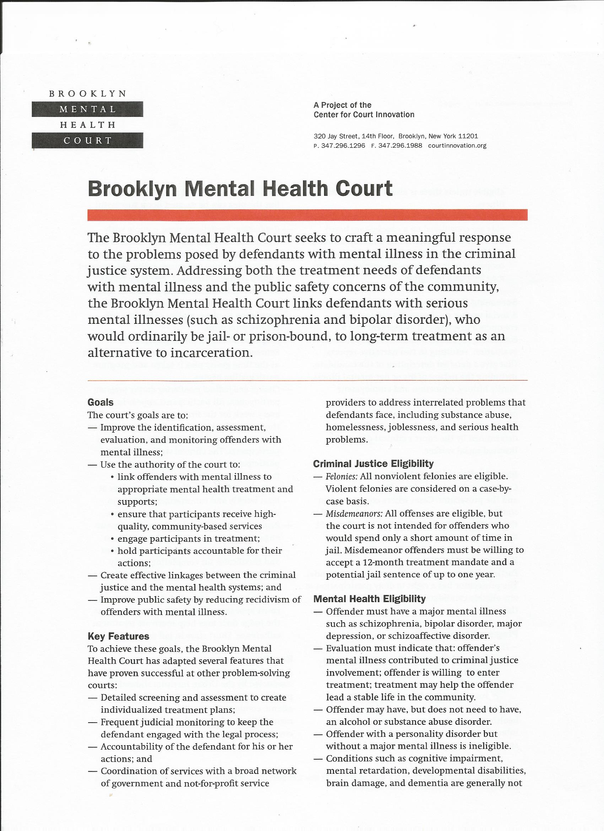
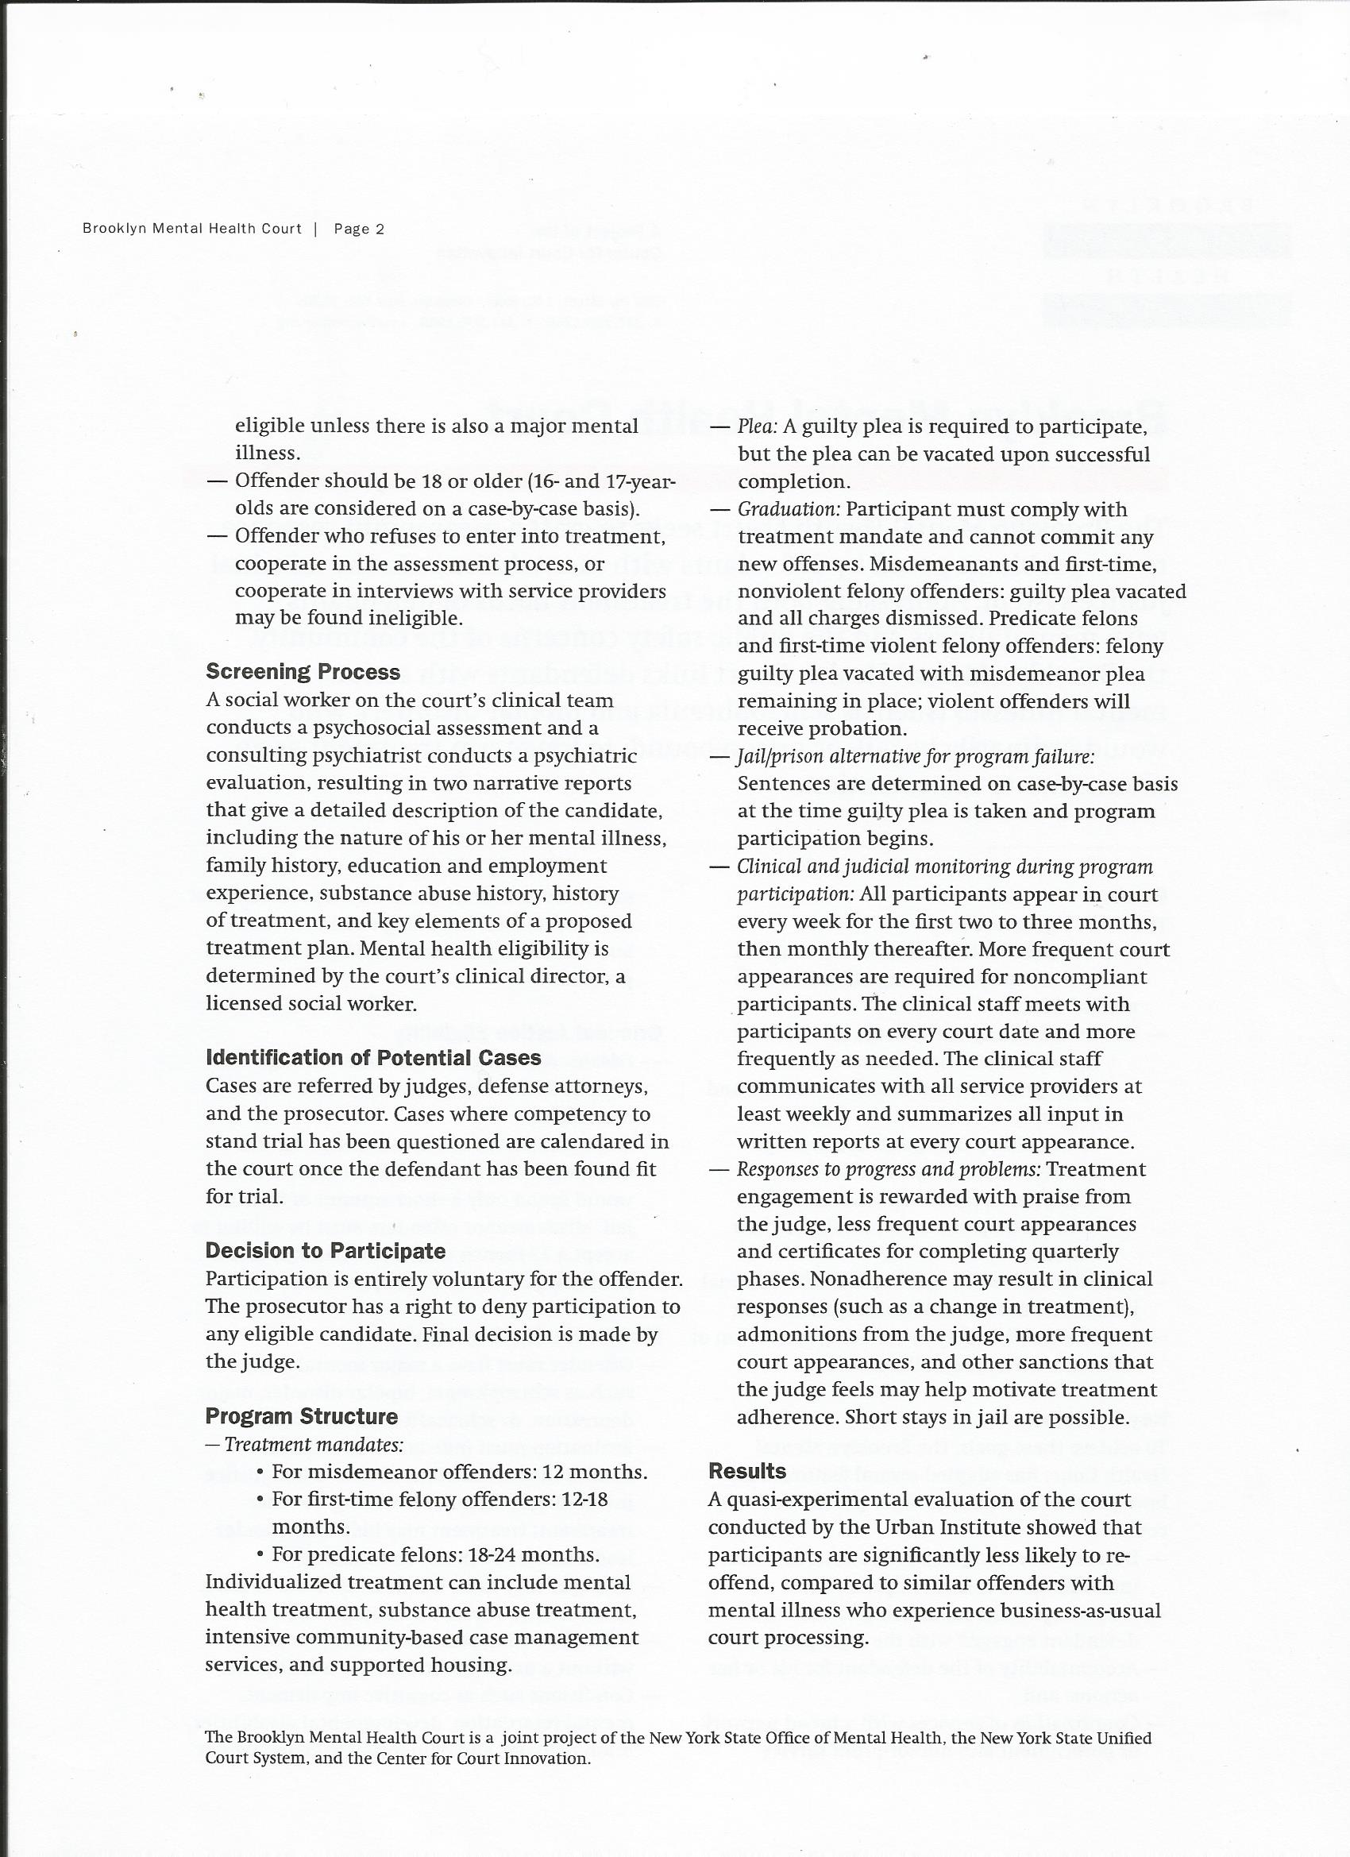
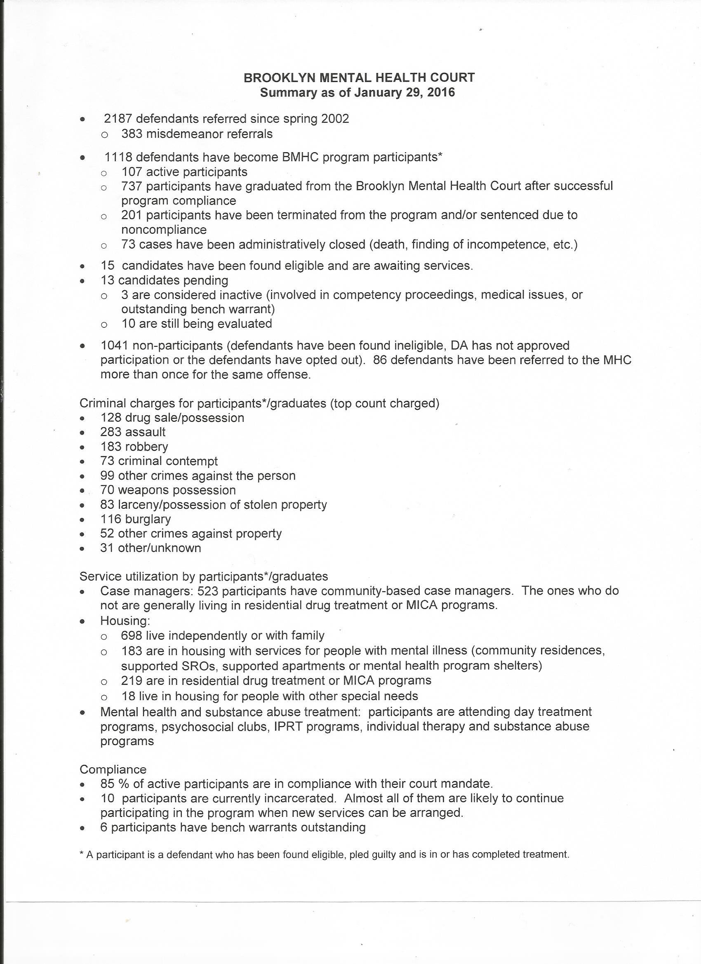
4B) Fact Sheet in relation to Brooklyn Mental Health Court

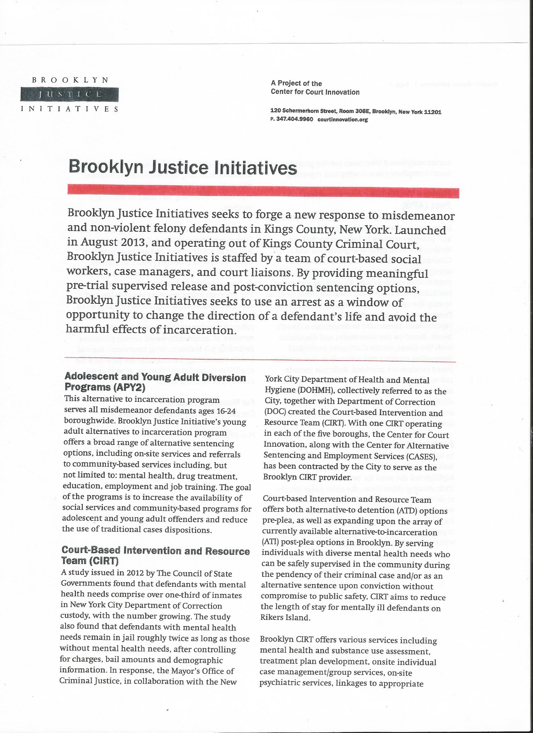

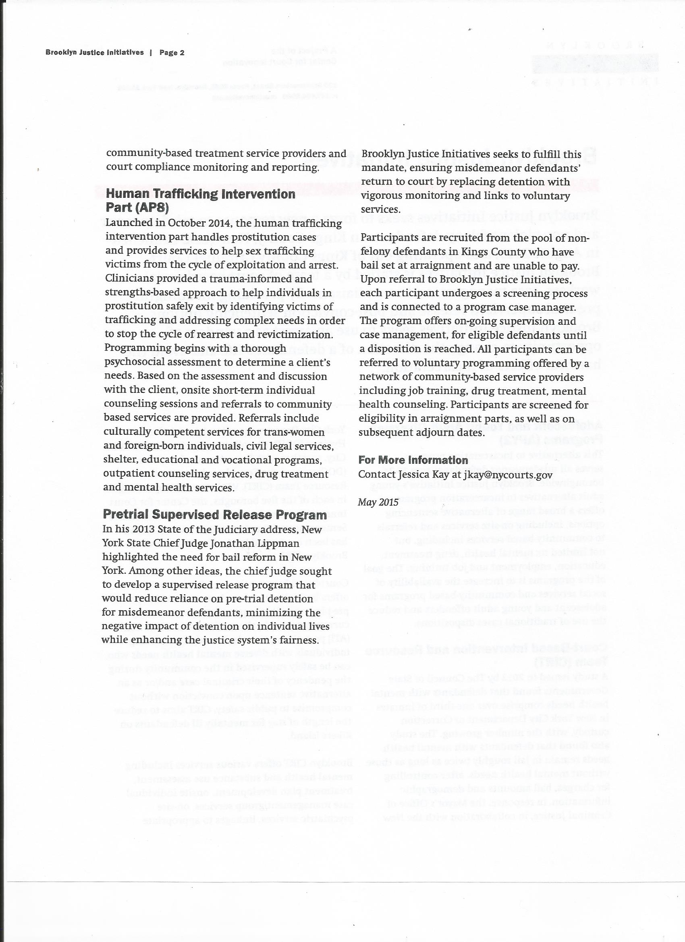

Rhodes Foundation Scholarship Trust
c/o 5th Floor, Oakland House,
Talbot Road, Manchester M16 0PQ
Telephone: 0161 872 4802

www.rhodesfst.com
@lordrhodes2106

Originally a study visited had been arranged to observe the Harlem Reentry Court, whereby cases that had been returned to custody were re-released under direction and supervision of a Judge and their progress monitored. However, due to a last minute operational issue, this visit did not progress and an alternative visit to meet with the Director of the Brooklyn Justice Initiatives was offered instead.

